INFOSYS INTERNSHIP
MILESTONE – 3 PROJECT REPORT
SUPPLY CHAIN VISIBILITY & OPTIMIZATION
Domain: Data Visualization
Submitted by
P.SUPRAJA
Infosys Internship – Supply Chain visibility and Optimization

1. Introduction
Milestone 3 focuses on evaluating supplier performance, transportation costs, route and carrier efficiency, and key operational indicators through Power BI dashboards. The dashboards convert supply-chain data into meaningful visual information for performance monitoring and decision-making.
The analysis covers Supplier Scorecards, Transportation Cost Analysis, Route & Carrier Performance Analysis and Advanced KPI Visualization. Interactive slicers and visuals allow analysis by product, supplier, location, carrier and transportation mode.

2. Objectives of Milestone 3
- Evaluate supplier performance using delivery, quality, cost and reliability indicators.
- Analyze transportation expenditure by transportation mode, location, carrier and product.
- Compare route and carrier performance using shipping time and shipping cost.
- Present important supply-chain KPIs through clear Power BI visualizations.
- Identify areas requiring cost, delivery and supplier-performance improvement.

3. Supplier Scorecards

Definition
Supplier Scorecards are a structured method of evaluating and comparing suppliers using measurable indicators such as delivery performance, quality, cost, reliability and business contribution.

Dashboard Explanation
The Supplier Scorecards dashboard provides a consolidated view of revenue, products sold, average price and stock levels. It also compares product types, customer demographics and locations to understand supplier-related business performance.
Dashboard Measure | Value / Observation
Sum of Revenue Generated | 8.84M
Sum of Number of Products Sold | 710.28K
Average Price | 48.26
Sum of Stock Levels | 75.62K
Revenue by Product Type | Skincare, Haircare and Cosmetics are compared
Location and Revenue | Revenue is visualized geographically

Key Findings
- Revenue generated is 8.84M and products sold total 710.28K.
- Average product price is 48.26 and total stock level is 75.62K.
- Revenue is compared across Skincare, Haircare and Cosmetics.
- Supplier performance can be evaluated together with product sales and inventory contribution.
- Location-based analysis provides geographical visibility.
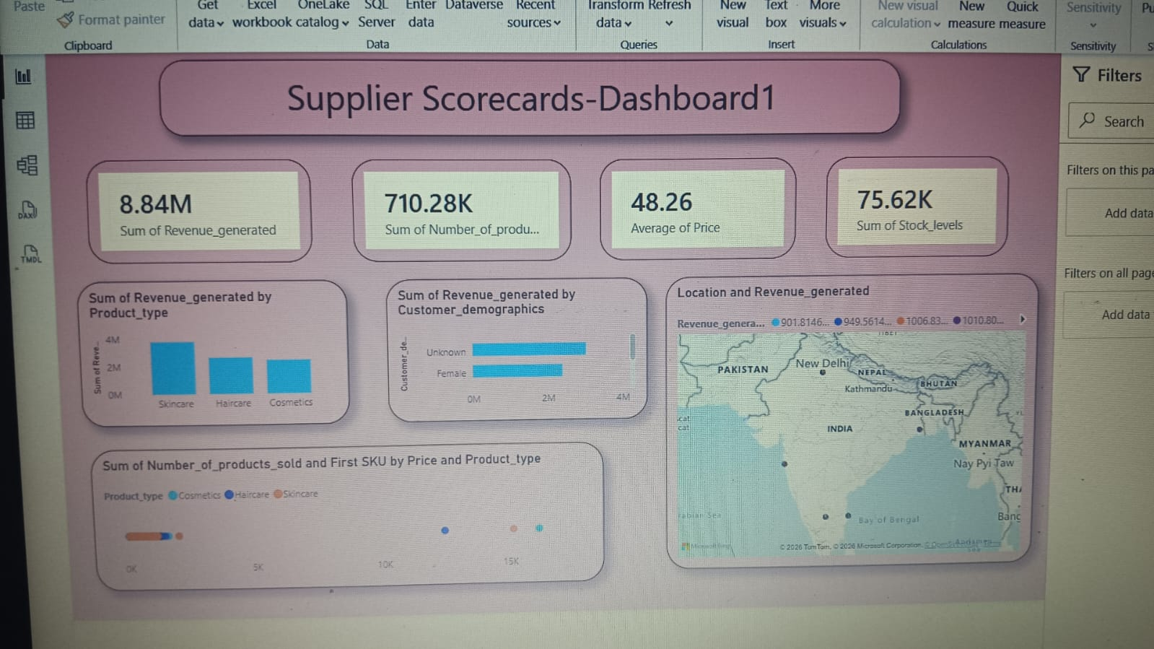
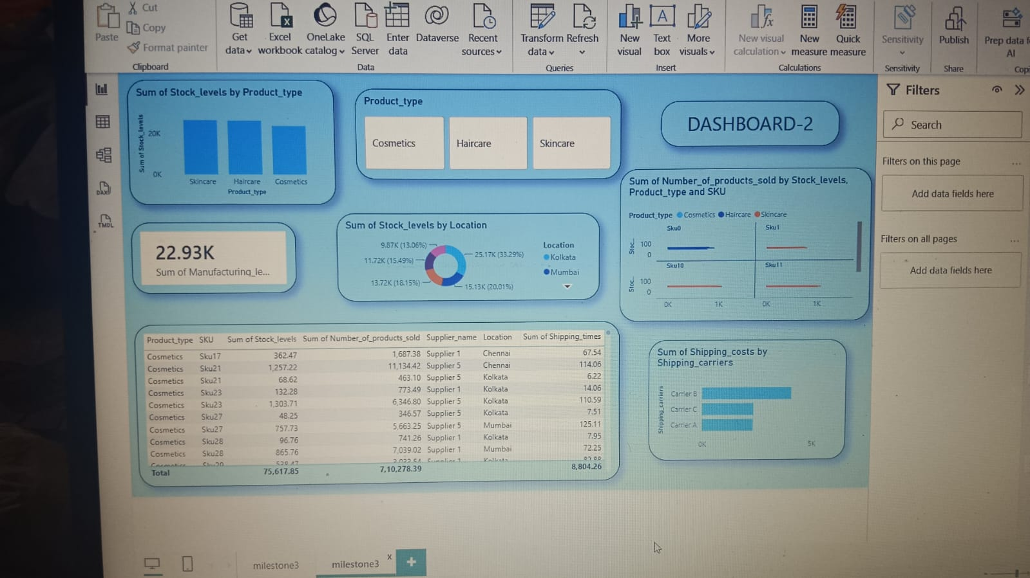

4. Transportation Cost Analysis

Definition
Transportation Cost Analysis examines logistics expenditure across transportation modes, locations, shipping carriers, routes and products to understand where transportation spending is concentrated.

Dashboard Explanation
The dashboard combines KPI cards, a geographical map, transportation-mode analysis, a decomposition tree, location-wise cost analysis and product/supplier comparisons.
Measure | Dashboard Value
Total Revenue | 8.84M
Total Products Sold | 710.28K
Average Shipping Cost | 5.67
Total Carriers | 3
Total Suppliers | 5
Total Orders | 2K
Road Shipping Cost | 3.01K
Air Shipping Cost | 2.33K
Rail Shipping Cost | 2.09K
Sea Shipping Cost | 1.27K

Key Findings
- Road has the highest displayed shipping-cost contribution among the transportation modes.
- Shipping costs are compared across Kolkata, Mumbai, Bangalore, Chennai and Delhi.
- Carrier-wise analysis compares Carrier A, Carrier B and Carrier C.
- The decomposition tree breaks shipping cost down by location, transportation mode, carrier, supplier and product.
- Interactive filters support detailed transportation-cost analysis.
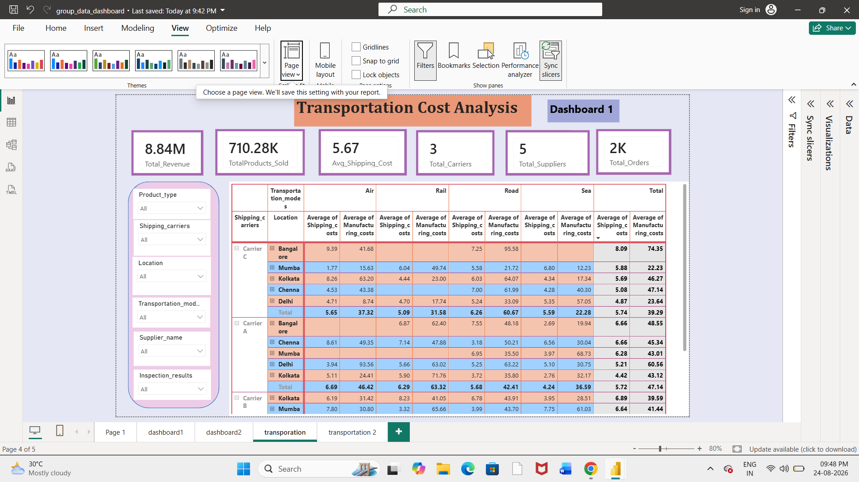
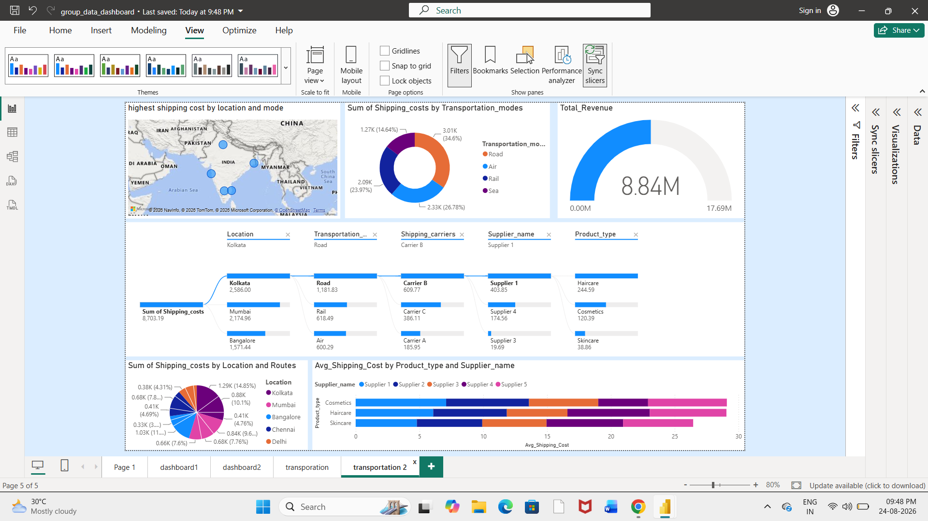

5. Route & Carrier Performance Analysis

Definition
Route & Carrier Performance Analysis evaluates transportation efficiency by comparing shipping time, shipping cost, routes, carriers and transportation modes.

Dashboard Explanation
The dashboard provides KPI cards and comparative visuals for carriers and routes. It includes average shipping time, average shipping cost, total transportation cost, carrier speed-versus-cost analysis, route shipping-time analysis and shipping-time decomposition.
Measure | Dashboard Value
Total Shipments | 1,535
Average Shipping Time | 5.74
Average Shipping Cost | 5.67
Total Transportation Cost | 811.51K
Carrier A Average Shipping Time | 6.2
Carrier C Average Shipping Time | 6.0
Carrier B Average Shipping Time | 5.3
Carrier C Average Shipping Cost | 5.7
Carrier A Average Shipping Cost | 5.7
Carrier B Average Shipping Cost | 5.6
Route A Average Shipping Time | 6.0
Route B Average Shipping Time | 5.8
Route C Average Shipping Time | 5.1

Key Findings
- Total shipments are 1,535 with an average shipping time of 5.74 and average shipping cost of 5.67.
- Carrier B has the lowest displayed average shipping time at 5.3.
- Average shipping costs are closely grouped across the three carriers.
- Route C has the lowest displayed average shipping time at 5.1.
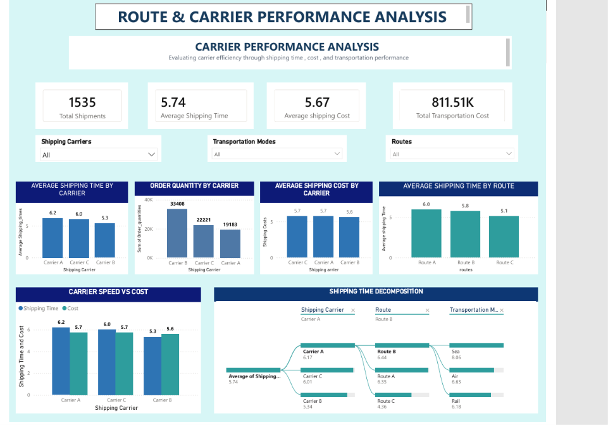

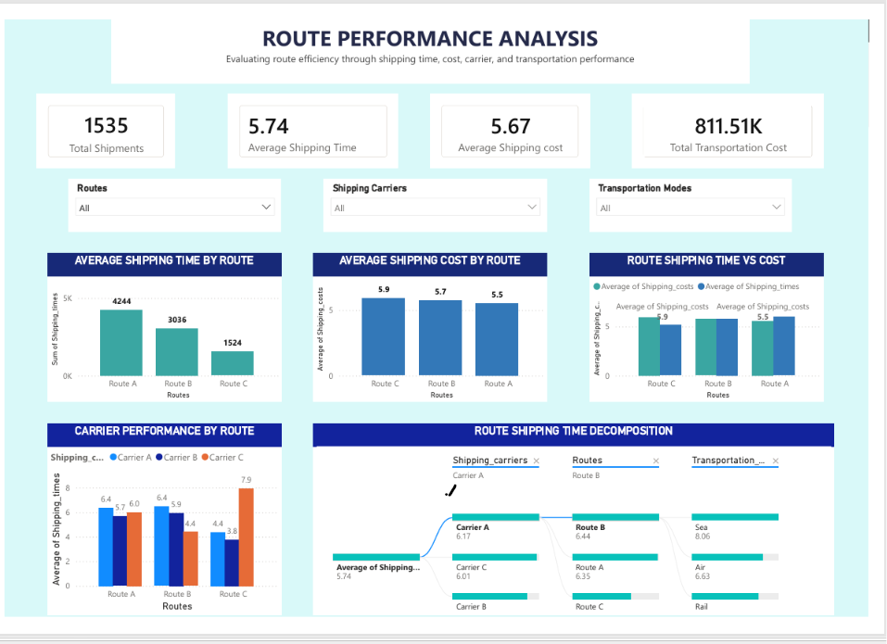

6. Advanced KPI Visualization

Definition
Advanced KPI Visualization combines important operational measures into meaningful performance indicators and visual comparisons for quick monitoring and decision-making.

Dashboard Explanation
The project dashboards use KPI cards, bar charts, donut charts, maps, decomposition trees, tables and interactive slicers. These visuals combine summary-level measures with detailed analysis.
KPI / Visual | Purpose
On-Time Delivery % | Monitor delivery reliability
Cost per Shipment | Monitor transportation efficiency
Average Delivery / Shipping Time | Monitor delivery speed
Supplier Rating / Performance | Compare supplier performance
Freight / Transportation Cost | Monitor logistics expenditure
KPI Cards | Provide quick summary values
Slicers | Filter by product, supplier, location, carrier and mode

Key Findings
- KPI cards provide quick access to important summary measures.
- Charts compare product types, carriers, routes and locations.
- Maps support geographical analysis.
- Decomposition trees provide detailed breakdowns of major measures.
- Slicers make the dashboards interactive and support focused analysis.
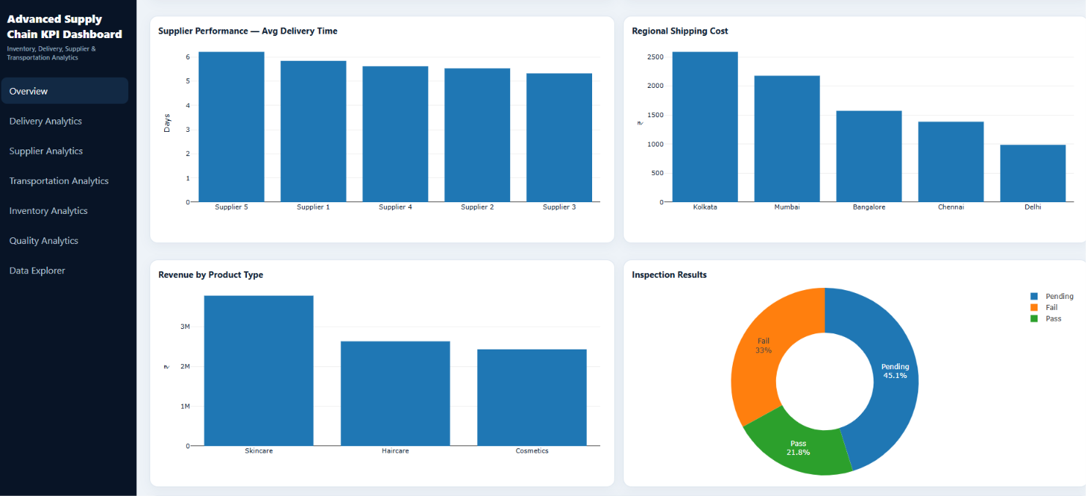
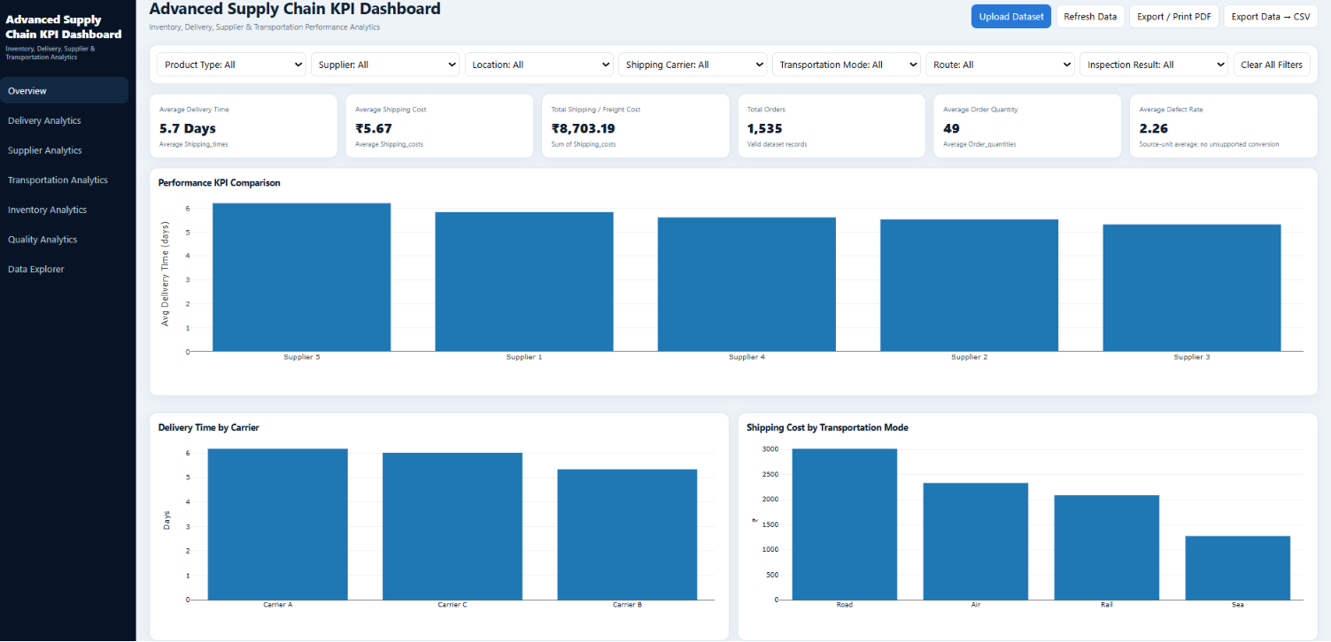

7. Consolidated Findings
- Supplier analysis provides visibility into revenue, product sales, stock levels and supplier contribution.
- Road has the largest displayed shipping-cost contribution among the transportation modes.
- The transportation dashboard records 8.84M total revenue, 5.67 average shipping cost, 3 carriers, 5 suppliers and approximately 2K orders.
- Route and carrier analysis records 1,535 shipments, 5.74 average shipping time and 811.51K total transportation cost.
- Carrier B has the lowest displayed average shipping time among the three carriers.
- Route C has the lowest displayed average shipping time among the three routes.
- KPI visualization combines operational indicators into an interactive decision-support view.

8. Recommendations
- Monitor supplier performance regularly using consistent supplier KPIs.
- Review transportation modes and locations with higher shipping-cost contributions.
- Compare carrier cost and shipping time together when evaluating transportation options.
- Investigate routes with comparatively higher shipping times for optimization opportunities.
- Use interactive filters for supplier-, carrier-, route- and location-level analysis.
- Continue monitoring KPI trends to identify changes in supply-chain performance.

9. Conclusion
Milestone 3 extends the Supply Chain Visibility & Optimization project by focusing on supplier, transportation, route and carrier performance. The Power BI dashboards provide visibility into supplier contribution, shipping costs, transportation modes, carrier performance and route efficiency.
The combination of KPI cards, comparative charts, maps, decomposition analysis and interactive filters provides a practical decision-support system for monitoring supply-chain performance and identifying opportunities for improvement.

10. Tools Used
- Power BI – Dashboard development, visualization, filtering and KPI presentation.
- DAX – KPI and business measure calculations.
- Python – Data preprocessing and analysis from earlier project stages.

